Where is..?

Word bank:
River
Crag
Bridge
Petrifying Well
Museum
Shops
Boat hire hut
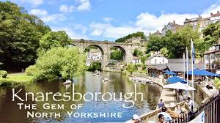

Where is Knaresborough castle?
__________________________________________________________________________________________________________________________________

What is near to the River Nidd in Knaresborough?
__________________________________________________________________________________________________________________________________

Where is Mother Shipton’s cave?
__________________________________________________________________________________________________________________________________

