Source: From the teacher, I learnt…
When was Knaresborough Castle built?

Miss Place said: ______________________________________________________
_________________________________________________________________

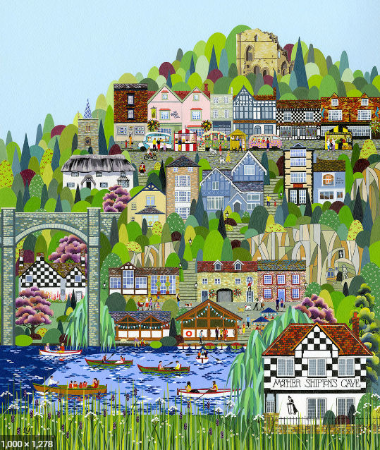
Source: From a painting by local artist, Linda Mellin, I learnt…
Is Mother Shipton’s Cave at the top or the bottom of the crag? ________________________________

Challenge: What was built at the top of the crag? _______________________________________
Extra Challenge: Why might it have been built at the top of the crag? ____________________________
________________________________________
________________________________________

Source: From an article in the local ‘Harrogate Advertiser’, I learnt…
What has been opened in Knaresborough in memory of those who passed away during the Covid-19 Pandemic?
_______________________________________________________________
Where is the new garden?
_________________________________________________________________
Would I like to visit the new garden?
_________________________________________________________________
