L.O. Adding Equal Groups 02.02.22

1 Star
How many wheels altogether?

2 + 2 + 2 + 2 + 2 = __

How many fingers altogether?
5 + 5 + 5 = ___

How many apples are there?
5 + 5 + 5 + 5 = ___

How many fish are there?

10 + 10 + 10 = ___

2 Stars
How many eyes altogether?

How many bananas altogether?

How many cherries altogether?

How many jellybeans altogether?

How many tomatoes altogether?
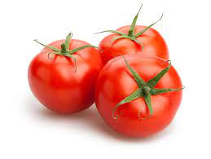

3 Stars
Write the repeated addition number sentences below as multiplication sentences.
E.g. 3 + 3 + 3 + 3 = 12 is the same as 4 x 3 = 12

4 + 4 = ____ is the same as ___ x ___ = ___

2 + 2 + 2 = ___ is the same as ___ x ___ = ___

5 + 5 + 5 = ___ is the same as ___ x ___ = ___

Challenge: Can you continue by using your own questions?

