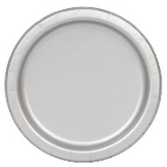  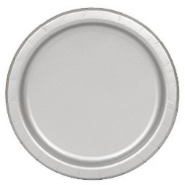  Share 12 cubes onto two plates. | There are ___ cubes altogether.  There are ___ two plates.  There are ___ cubes on each plate.
Share 15 cubes onto three plates | There are ___ cubes altogether.  There are ___ two plates.  There are ___ cubes on each plate.
Share 16 cubes onto four plates. | There are ___ cubes altogether.  There are ___ two plates.  There are ___ cubes on each plate.
Share 20 cubes onto five plates. | There are ___ cubes altogether.  There are ___ two plates.  There are ___ cubes on each plate.

Share 15 beanbags between 5 hoops.  15 ÷ 5 = __ | 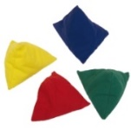  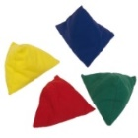
Share 8 beanbags between 4 hoops.  8 ÷ 4 = __ | 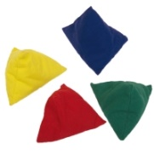
Share 16 beanbags between 4 hoops.  16 ÷ 4 = __ | Share 9 beanbags between 3 hoops.  9 ÷ 3 = __

3 Star Questions

Jane has 10 sweets and shares them between 2 friends.
Tom has 10 sweets and shares them between 5 friends.
Whose friends will receive the most sweets?
How do you know?

Challenge: Can you make your own question up similar to the one above?

