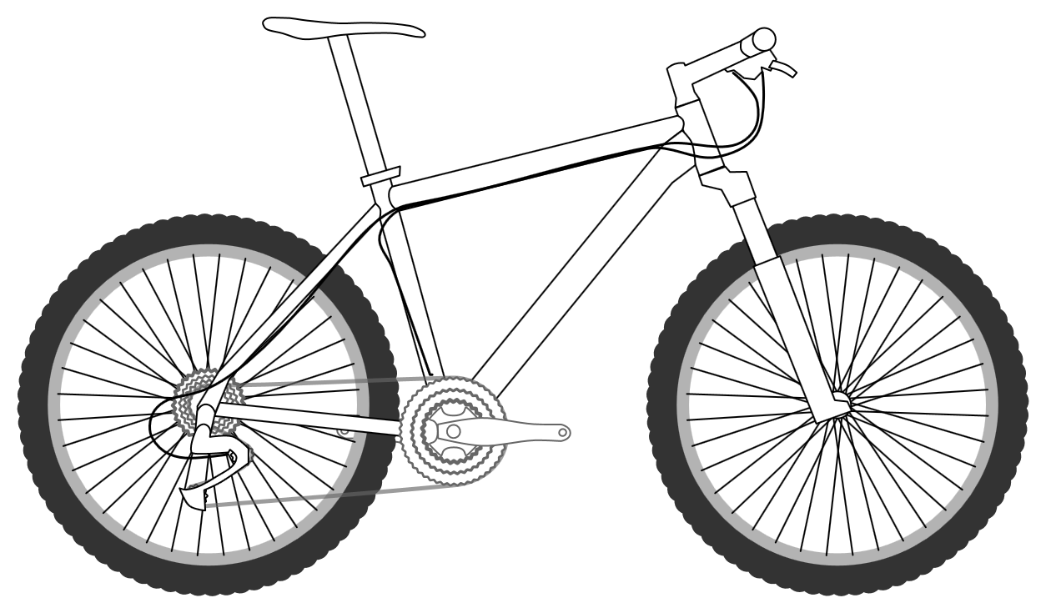

**In order, what does Mrs Armitage add?**

First, Mrs Armitage adds _____________________________________________________. Then, Mrs Armitage adds ________________________. Following this, she adds _______________________________________________ and _____________________________________. The inventive Mrs Armitage also adds ____________________________, ______________________________________ and _____________________________________________. Finally, she adds _______________________________________________!

**Draw Mrs Armitage’s additions onto the bicycle below.**

Name:_________________

Mrs Armitage’s bicycle invention