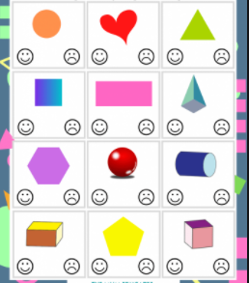

Challenge: Think of some other 2D and 3D shapes. Can you draw them and then find examples of them in your house?

